4.2 TEST MS

1. (a) Total moles n = pV/RT (1)
= 1.59 × 106 × 1.04 × 10–3/(8.31 × 380) = 0.524 moles (1)
Moles of methanol 0.524 – 0.122 – 0.298 = 0.104 moles (1) 3
(b) Kc = 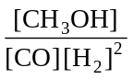 (1)
=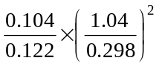
= 10.4 (1)
dm6 mol–2 (1) 3
[6]

2. (a) (i) C + 3D 2A + B 1
(ii) mol–1dm3 1
(iii) (forward reaction is) exothermic or more products formed 1

(b) (i) for N2O4 Mr = 92.0 1
Mol = 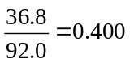 1
(ii) mol N2O4 reacted = 0.400 – 0.180 = 0.220 1
mol NO2 formed = 0.440 1
(iii) Kc = (NO2)2 1
(N2O4)
= (0.44/16)2 1
(0.18/16)
= 0.067 1
(iv) move to NO2/ to right / forwards 1
none 1
[12]

3. (a) (i) moles of C2F2 = 0.40 mark independently from HC1 1
moles of HC1 = 0.80 not consequential 1
(ii) 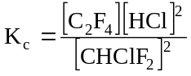
wrong Kc means they can only 1
score for units in (iii) consequ
on their Kc
(iii) 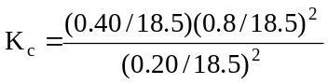 1
= 0.35 1
mol dm–3 1
(b) (i) increase 1
(ii) decrease 1
[8]
4. (a) (i) Number of moles of O2 at equilibrium: 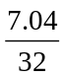 = 0.22 (1) 1
Number of moles of NO at equilibrium: 0.44 (1)
OR 2 × mol of oxygen
(ii) Original number of moles of NO2: 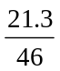 = 0.46(3) (1)
Number of moles of NO2 at equilibrium: 0.46(3) – 0.44 = 0.02(3) (1)
OR conseq on mol NO above
3
(b) Expression for KC: KC = 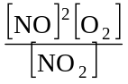 (1)
Calculation: KC = 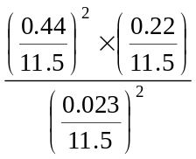 = 7.0(0) mol dm–3
(1) (1) (1)
If mol NO2 = 0.02; KC = 9.26 (9.3)
or conseq on values from (a)
If vol missed, score only KC and units
If KC wrong: max 2 for correct use of vol and conseq units
If KC wrong and no vol: max 1 for conseq units
3
(c) pV = nRT (1)
T = 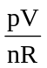 = 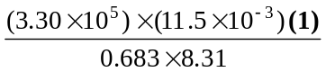
(1) for using 11.5 × 10–3 as V
T = 669 K (1) 4
(d) Yield of oxygen: increased (1)
Value of Kc: no effect (1) 2
[13]

5. (a) (i) exothermic (1)
yield decreases as temperature increases (1)
(this mark dependent on first mark) 2
(ii) vanadium (V) oxide / vanadium pentoxide / V205 (1)
yield of sulphur trioxide unchanged (1)
not just reference to position of equilibrium
(both / forward and reverse reaction) rates increase (1)
equally (1) 4
(iii) advantage – higher yield of (sulphur trioxide) / equilibrium
moves to the right (1)
not “saves energy costs”
disadvantage – slower rate of reaction / lower throughput (1) 2
(b) (i) rate increased (1) 1
(ii) % yield increased / more SO3 / equilibrium shifts to the right (1)
fewer (gas) moles on right hand side of equation increased
pressure favours (1)
smaller number of mols / molecules / volume 2
[11]

